**Rietveld, Gerrit Thomas (1888–1964)**

Gerrit Rietveld was a Dutch furniture designer and architect associated with the avant-garde movement known as DE STIJL (The Style). Influenced by the abstract paintings of PIET MONDRIAN, Rietveld’s work emphasised pure geometric form and primary colours. As the principal interpreter of the De Stijl aesthetic, Rieveld demonstrated how Mondrian’s abstract style could be translated into three dimensional design objects and buildings. His work helped to formulate many of the principles that became integral to Modernist design of the 1920s and 30s.

Born in Utrecht, Rietveld was the son of a cabinet-maker. He worked with his father from the age of eleven and this experience gave him a thorough grounding in craft skills. He then worked as a draughtsman for a jeweller in Utrecht from 1906 to 1911. Opening his own furniture workshop in 1917, he established himself as a cabinet-maker and attended night-school to study architecture.

Rietveld designed his now-famous Red-Blue Chair in 1918. This was originally an unpainted piece, extolling the virtues of simple craftsmanship. The following year, however, Rietveld encountered the pioneering work of THEO VAN DOESBURG and Piet Mondrian, the principal members of De Stijl. Rietveld joined the group and painted the chair in the signature De Stijl colours in 1923, thus transforming it into a three-dimensional realisation of a Mondrian painting. The joints extend beyond their point of contact, suggesting that the chair was merely an ensemble of planes and lines coalescing in infinite space. 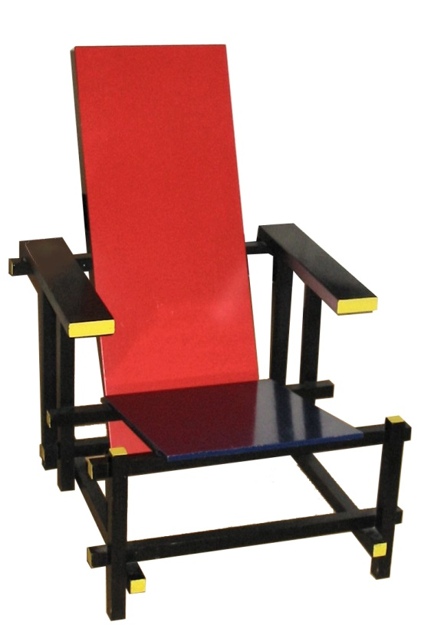

Gerrit Rietveld, Red-Blue Chair, 1918

<http://en.wikipedia.org/wiki/File:Rietveld_chair_1.JPG>

In 1921 Rietveld designed a jewellery shop in Amsterdam, which successfully applied the new aesthetic to architecture and interior design. However, the most complete expression of De Stijl principles is the Schröder House (1924), designed for Mrs Truus Schröder and built in a conventional suburban area of Utrecht. The elevations are fractured into a series of planes and lines suspended in space and colour is used to articulate their rhythm. The Dutch word ‘stijl’ can also mean a post, jamb or support and this is visualised in the form of the building, where the structural supports are emphasised by the use of colour. Such honest expression of structure became a central tenet of Modernist architecture. The emphasis on rectangular planes establishes a powerful visual unity between interior and exterior. Internally, the various rooms are separated from each other by loose sliding partitions, which enabled the owner to reconfigure the space.

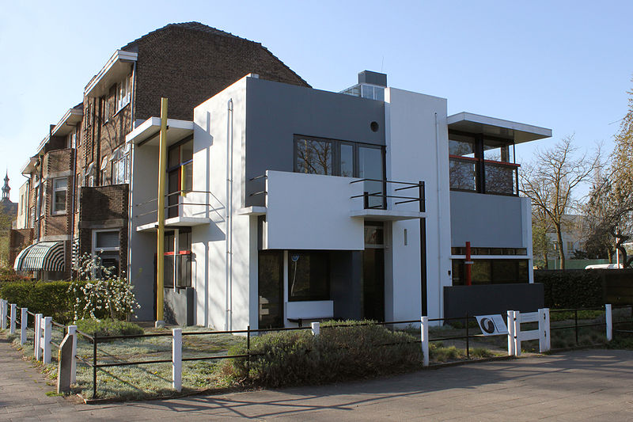

Gerrit Rietveld, Schröder House, 1924

<http://upload.wikimedia.org/wikipedia/commons/a/a7/Rietveld_Schr%C3%B6derhuis_HayKranen-20.JPG>

Rietveld’s experiments drew the attention of radical designers throughout Europe. In 1923, WALTER GROPIUS invited him to exhibit at the BAUHAUS. Rietveld’s emphasis on formal purity had a profound influence on Bauhaus theory and practice, and subsequently on the whole gamut of Modernist design.

During the 1930s Rietveld gravitated away from De Stijl and engaged with a more functionalist and socially-orientated mode of architecture known as [Nieuwe Bouwen](http://en.wikipedia.org/wiki/Nieuwe_Bouwen) (New Building). His later work has received less attention, but he became increasingly concerned with social housing, experimenting with new materials and construction techniques. In 1951 Rietveld designed a retrospective international exhibition about De Stijl. This reignited interest in his work and earned him a number of prestigious commissions, including the Dutch pavilion for the Venice Biennale (1953) and the press room for the UNESCO building in Paris. In 1963 he designed the Van Gogh Museum in Amsterdam, but this was not completed until after his death.

**List of works**

Küper, M. and van Zijl, I. (1992) *Gerrit Th. Rietveld, 1888-1964: the complete works*. Utrecht: Centraal Museum Utrecht. (An exhaustive, highly-detailed monograph which examines Rietveld’s complete oeuvre. The volume includes a catalogue of over 680 works by Rietveld).

Vöge, P. and Overy, P. (1993) *The Complete Rietveld Furniture*. Rotterdam: 010 Publishers. (The most complete survey of Rietveld’s furniture design, with a detailed analysis of each piece. The volume is illustrated with photographs and original drawings).

**References and further reading**

Brown, T.M. (1958) *The Work of G. Rietveld*, Cambridge: MIT Press. (The first monograph to be published on Rietveld. The volume includes translations of Rietveld’s essays and a selected catalogue of works).

Mulder, B. and van Zijl, I. (1999) *Rietveld Schröder House*. New York: Princeton Architectural Press. (A concise analysis of the Schröder House, this book explores the role of the patron and the design and construction process, and is well-illustrated with plans and photographs).

Overy, P., Büller, L., Den Oudsten, F. and Mulder, B. (1988) *The Rietveld Schröder House*, London: Butterworth Architecture. (A study of the Schröder House, including an interview with Truus Schröder and a discussion of the restoration of the house conducted by the architect Bertus Mulder).

White, M. (2003) *De Stijl and Dutch Modernism.* Manchester: Manchester University Press. (This is the first book to view the De Stijl movement within the context of Dutch Modernism, exploring debates concerning abstraction in painting and spatiality in architecture).

Van Zijl, I. (2010) *Gerrit Rietveld*. London: Phaidon. (A detailed, but accessible monograph that examines Rietveld’s role in De Stijl and his later engagement with mass housing and industrial production. The text is richly illustrated with photographs).